# Hands-on Lab : Save your PowerPoint Presentation as PDF

Estimated time needed: 5 minutes

Microsoft PowerPoint is the most widely used presentation software even three decades after its initial release. For all these years it has been available as a standard application that needed to be installed on your desktop; but it is not just a desktop app anymore. Now, you can even use PowerPoint when you're online by using 'PowerPoint for the web' - and run it right in your web browser without installing anything on your desktop!

'PowerPoint for the Web' (sometimes referred to as PowerPoint Online) can be used at no charge as part of a free Microsoft account. Although it does not have all of the capabilities of the desktop and paid online versions, the free web version provides many of the key features.

# Software Used in this Lab

For the story telling/project report of this module, you will be using the free 'PowerPoint for the web' version as this is available to everyone.

Although you can use the PowerPoint Desktop software if you have access to this version, it is recommended that you use PowerPoint for the web for your project report as it is available for free, and there are some small differences in the interface and available features. If you do not yet have access to PowerPoint for the Web, you can follow the instructions in the following lab to get started with it: [Hands-on Lab - Getting Started with PowerPoint for the Web](https://cocl.us/DA0321EN-Lab-Getting_Started_with_PowerPoint_for_the_Web)

# Objectives

After completing this lab, you will be able to:

* Save your PowerPoint Presentation as PDF in PowerPoint for the Web
* Save your PowerPoint Presentation as PDF in PowerPoint Desktop for Windows/macOS

# Exercise 1: Save your PowerPoint Presentation as PDF in PowerPoint for the Web

In this exercise, you will save your PowerPoint presentation as PDF in PowerPoint for the web.

1. Open your presentation file with PowerPoint for the web.  
   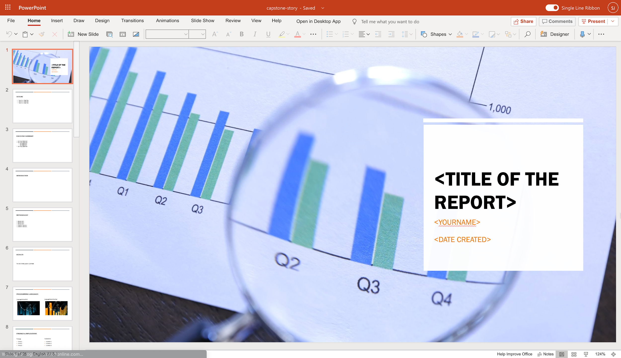
2. Click File.  
   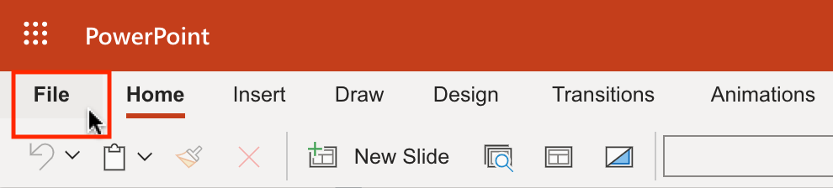
3. Select Download As. Then select Download as PDF.  
   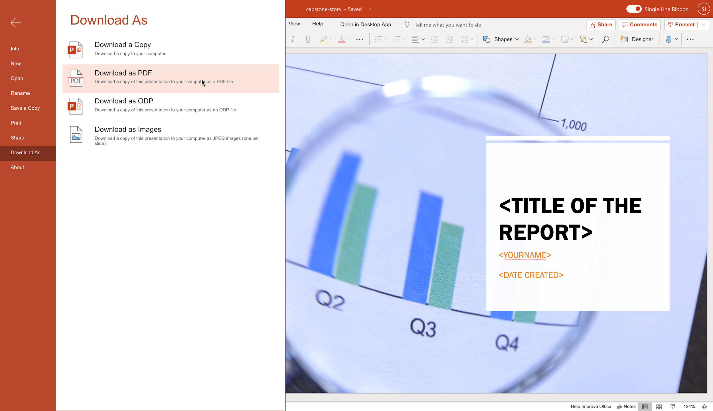
4. Click Download.  
   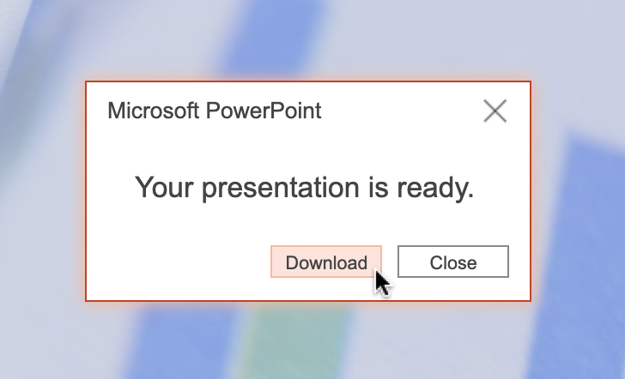
5. Save to your local storage.

# Exercise 2: Save your PowerPoint Presentation as PDF in PowerPoint Desktop for Windows/macOS

In this exercise, you will save your PowerPoint presentation as PDF in PowerPoint Desktop for Windows/macOS.

1. Open your presentation file with PowerPoint Desktop for Windows/macOS.  
   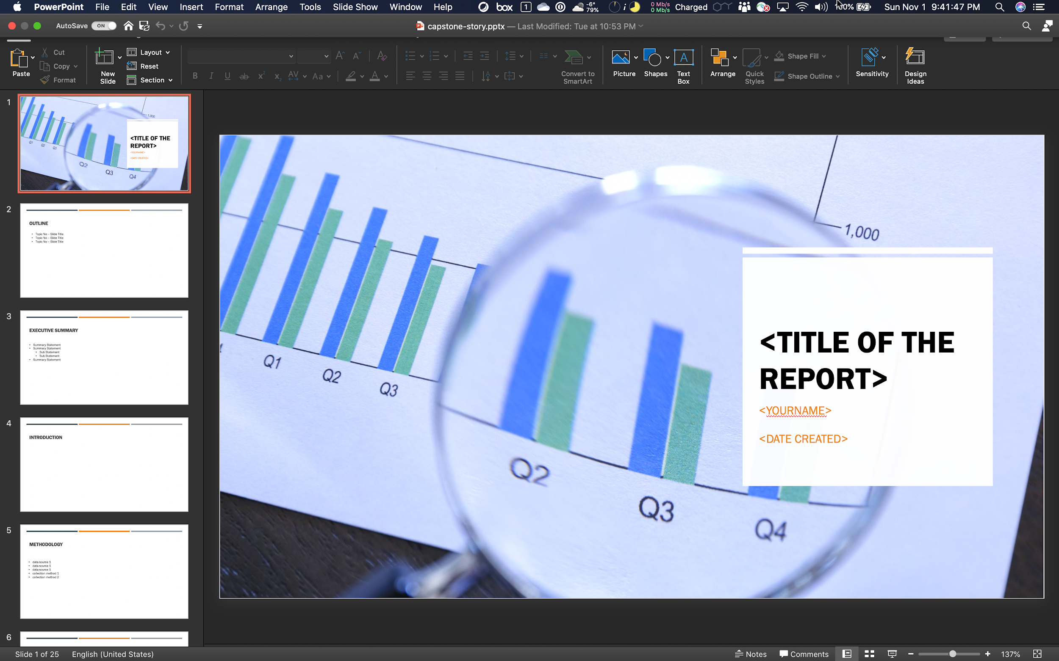
2. Click File. Then select Export....  
   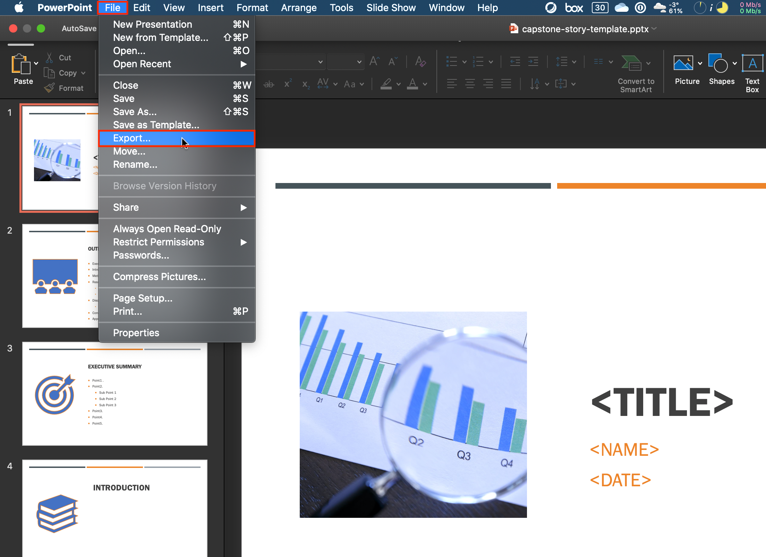
3. To save the file as PDF to your local storage, click Export making sure the File Format specifies PDF.  
   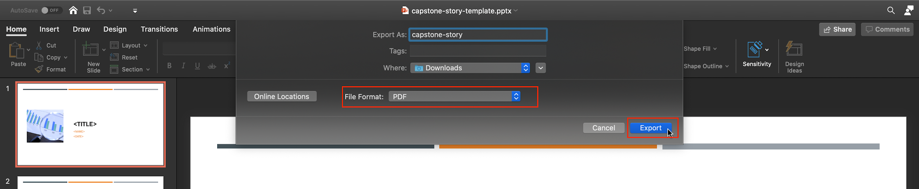

### Congratulations! You have completed this Lab.